Quick Reference Guide

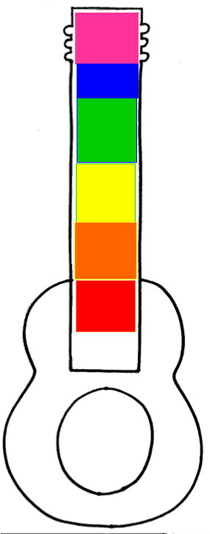
PINK
You’re a Rockstar! Welcome to Hollywood
Student Earns a Rockin’ Sticker & “Good News from School” postcard

BLUE
A Stellar Performance! Keep it up!
Student Earns a Rockin’ Sticker

GREEN
Let’s Rock ‘n’ Roll! You’re ready to learn!
Student begins here.

YELLOW
Singin’ the Blues. Practice Makes Perfect.
Student receives warning.

ORANGE
Speak with management.
Student receives a consequence and/or parent contact.

RED
All tour dates cancelled.
Student receives consequence. Principal and parents are contacted.

A Behavior Management System

Our classroom employs a clip chart behavior management system adopted from the clip chart system developed by Rick Morris. This system promotes positing behavior choices and encourages students to self-monitor their behavior.

How it works…
- Each student has a clothespin labeled with his/her name.
- Each class all students begin with their clothespin at the center of the chart on the color green, “Let’s Rock ‘n’ Roll! – Ready to Learn!”.
- During the course of the class, students move their clothespin up or down based on their behavior choices. Positive behavior choices are the two levels above the green level. Inappropriate behavior choices are the three levels below green. Each level has a reward or consequence that is clearly stated.
- At the end of class rewards are given to the students. Consequences are given to students as needed.

Clip Chart Advantages
- Students are acknowledged for positive behavior choices.
- Students feel a sense of accomplishment when they make a good behavior choice and have the opportunity to clip up.
- Students who have to clip down have the opportunity to improve and clip up throughout class.
- Consequences and Rewards are clearly stated.

